# Flawless Feedback Scenario

## ****Units and Assessments****

This semester, you have 3 related units of competency in your subjects. These subjects each have their own individual assessment items (which you can find on Connect). However, each of these assessment topics is focusing on certain parts of the software development life cycle. What this means is that even though these units are assessed individually, the work you produce for each unit will contribute greatly to the work you require in another unit. This document is here to provide you with a framework that will allow you to tie your projects together to reduce your overall workload while still giving you an authentic project.

A simpler way to view your assessments is as one large project, with a collection of subtasks (the tasks in your assessment documents). Later in this document, you will be provided with a scenario and some feature requirements. You will use your software design and software development skills (ICTPRG532 - programming) to create a modern web application (ICTWEB503) addressing the needs of the client. The application will have its data needs delivered via a web service running on a cloud platform (ICTPRG604).

*ICTPRG532 – Build a front end (client facing) web application connected to a back end Service (WebAPI) that in turn works with a relational database   
ICTWEB503 – Improvements / Modifications to Front End application to improve User Experience  
ICTPRG604 – Deploy Web API and Database, Deploy Front End application, Test connection and functionality*

***Each unit will have its own small scenario document and relevant Assessment documents***

**Note: you will want to review the other assessment documents within Connect - the assessments themselves have requirements that may not be explicitly stated in this document.**

## Scenario

***This scenario is related to the scenario of the unit ICTPRG523 - Apply advanced programming skills in another language. The developed applications will provide different functionality based on similar scenarios.***

You have been approached by a company called “Flawless Feedback”. This company has spent years successfully creating feedback surveys for their clients on physical media, specialising in paper-based surveys and feedback items.

Flawless Feedback have decided to take the plunge and move their offerings to the digital world – asking for your expertise in developing Software Applications on their new endeavour.

Your client has requested that the application to be developed is to be directed at their clients, to provide a system for clients to access an application and create custom feedback and survey items.

For this to be achieved, the application will need to be a modern, cloud based application that connects to a secure, cloud hosted API (to allow for further services to be developed in the future) that in turn connects to a cloud hosted Database. The client is happy for the application to be developed in stages as below

*The proposed application will not be required to provide functionality around users completing surveys or feedback forms, the focus is on generating the content that will be displayed on a feedback form*

**The application development has been split up into the following stages:**

First Stage (ICTPRG532 API and Database)

A Back-End service and SQL Server Database that will provide Create and Read functionality and data storage for Surveys, Questions and Options. The service will need to be able to return both single records and lists of records for each of the items mentioned including returning a list of Questions for a specified Survey and a list of Options for a specified Question.

## Second Stage (ICTPRG532)

Web Application designed and developed to provide a User Interface for the functionality created in the Web API

* *Create multiple* feedback **questions** per **Survey**
* *Create* multiple possible **options** for a **question**
* *View* a list of all **Surveys**
* *View* a list of **questions** attached to a **Survey**
* *View* a list of possible **responses** attached to a **question**

Extended functionality

* *Add* an existing **question** and attached **options** to a **Survey**
* *Add* existing **options** to a **question**

## Third Stage (ICTWEB503)

* Edit and Delete functionality added to API
* Custom Login page created for Web Application (for admin login)
* Token Authentication system added to API
* Login Page linked to API Token authentication
* Admin Login to allow for *Editing and Deleting* Feedback Forms, Questions and Responses

**First Submission – WEB503**

## Fourth Stage (ICTPRG532, ICTPRG604)

* Drag and Drop feature to allow for adding images (logo) to Feedback Forms
* Charting feature to allow for a graphical representation of the number of questions per survey
* An export feature, to export the Feedback form in CSV format
* Deploy API + Database to Azure
* Connect Web application to Azure hosted API
* Deploy Web application to Azure
* Test all functionality

## ICTPRG532 Specific Requirements

1. The user interface is to be a modern web application
2. The data needs to be delivered through a secure, documented web service or API
3. The developed Web Application or Web Service must make use of Interfaces and design patterns including at least one nested class
4. The final application is required to provide a help page, this can be in the form of a FAQ, User guide or any other form of instructional help page
5. The developed Web Service must be documented, if an API is developed, using a variation of the OPENAPI specification is advised.

## Data Requirements

1. Each **Survey** will be made up of the following:
   1. Survey title
   2. Survey Topic
   3. Creator Name
   4. Date Created
   5. Further Comments
   6. Company Logo or other image (this can be stored as text in the database)
   7. *A series of questions as outlined next*
2. Each **Question** needs to consist of the following:
   1. Question Text
   2. *A series of Options or Answers (at least 4) as outlined next*
3. Each **Option** will be made up of:
   1. Option text (possible answer to the question)
   2. Option letter/number (for ordering the options)

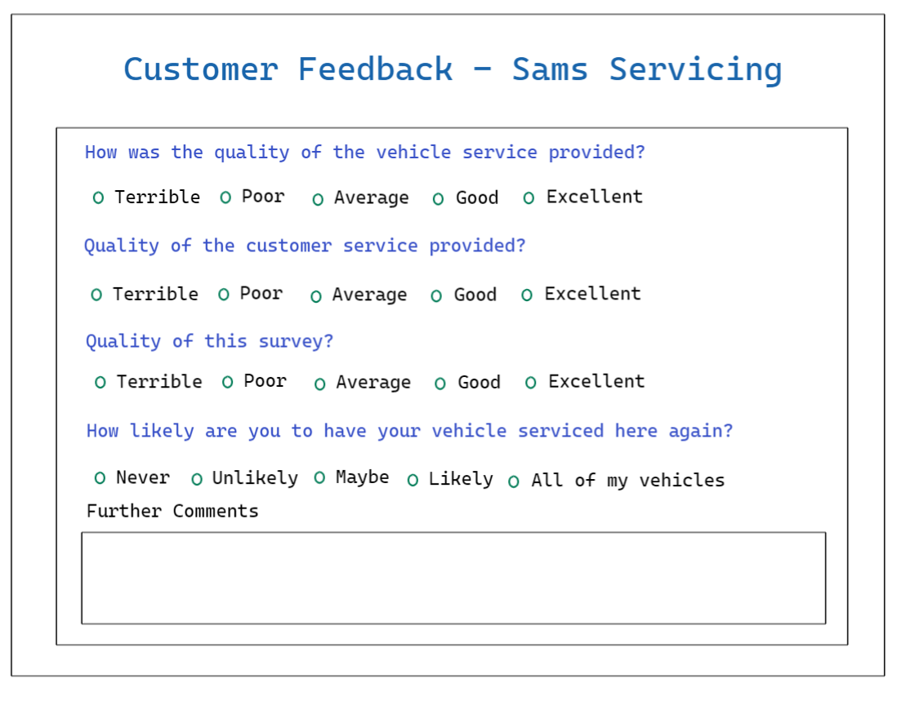***An example of a survey that could be created using this application is below***